PERTH MODERN SCHOOL
UNIT 3CD MAS – 2014
TEST 1
POLAR COORDINATES, COMPLEX NUMBERS & VECTORS

NAME: DATE: Thurs. 13th Feb.
Total: 43 marks Time: 45 min.

1. Z is a complex number. Sketch the region given by [5]
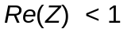 and 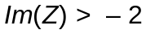 ☑
and 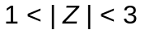 ☑
and 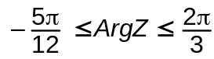 ☑
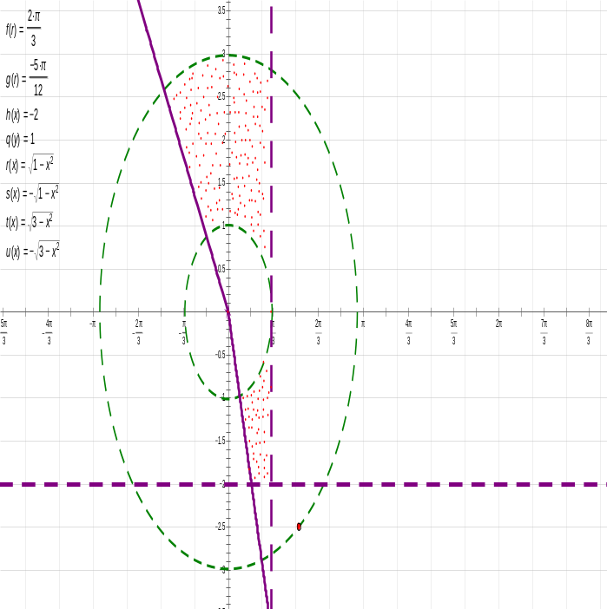

- ☑ for correct shading

2. Express 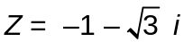 in polar form. [2]
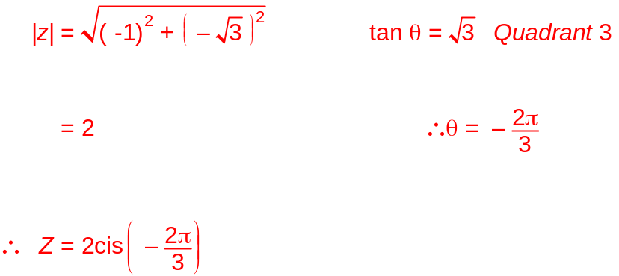

☑

☑

3. If 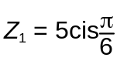 and 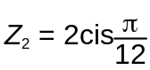 , then prove 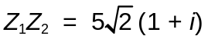 [4]
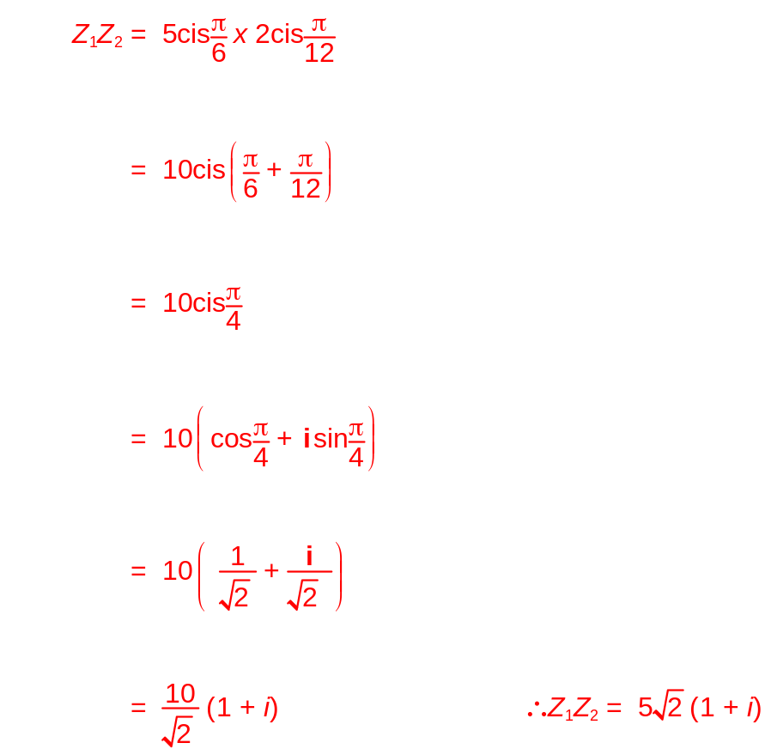

☑ ☑

☑

☑

4. Find 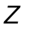 if 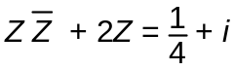 [6]
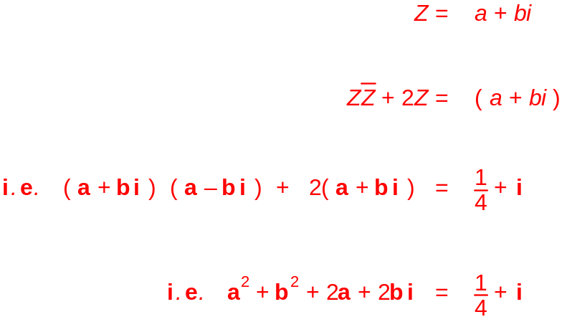 Let ☑

☑

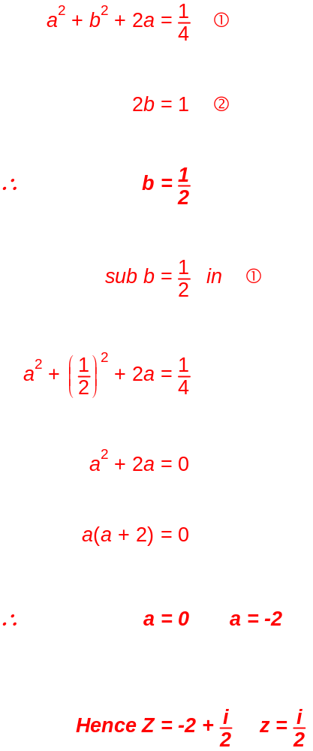 Compare real, imaginary
☑

☑

☑

☑
5.
Consider the 3D position vectors [8]
Determine:
a) the length of 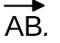
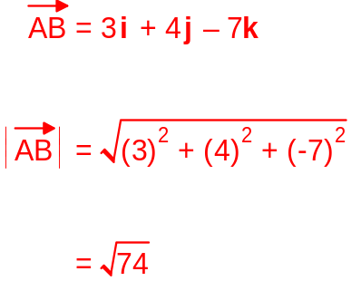
☑

☑
b)
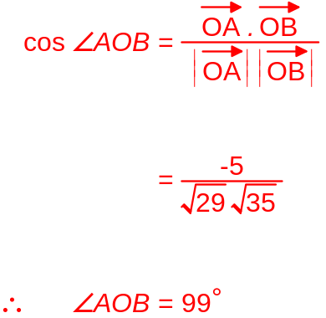

☑

☑
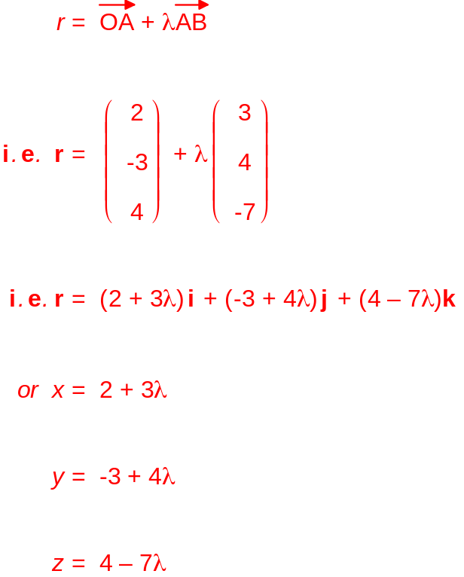c) the vector equation of the line, in parametric form, through the points A and B.

☑

☑

☑

☑
6. [8]
A has the rectangular coordinates 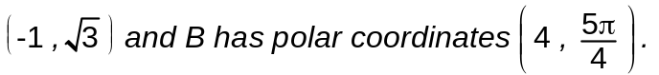
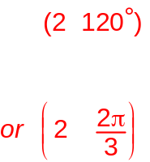a) What are the exact polar coordinates of A? (1)

☑

b) What are the exact rectangular coordinates of B? (2)
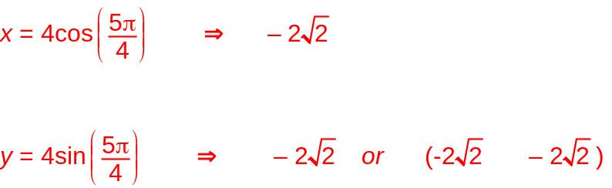
☑

☑

c) The graph of the polar equation 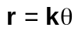 passes through the point B.
If 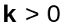, determine the value of k.
Then, on the axes below, sketch the graph of 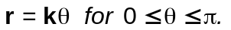,
showing important features. 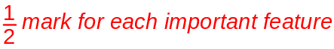 (5)
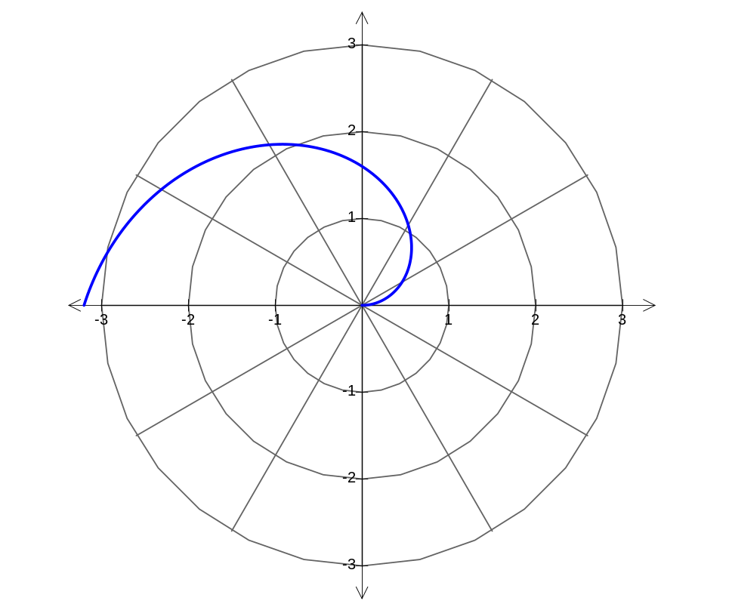



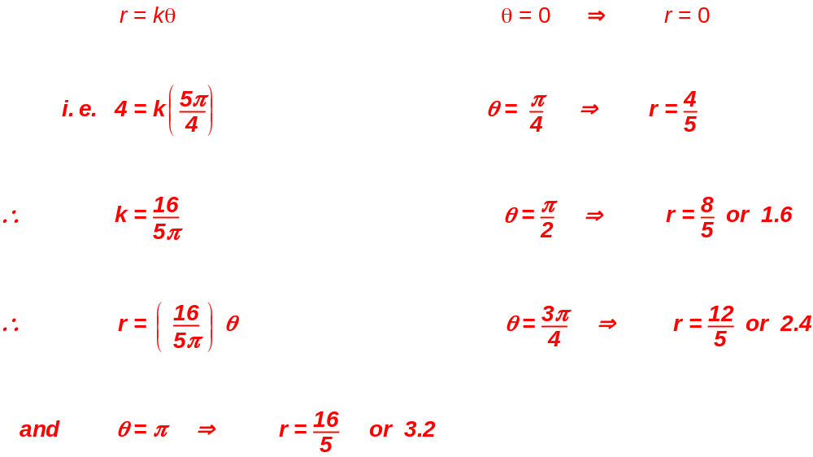

7. [10]
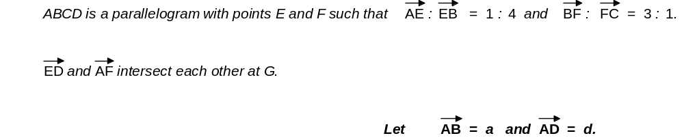

a) Complete the diagram below with the information given above. (2)

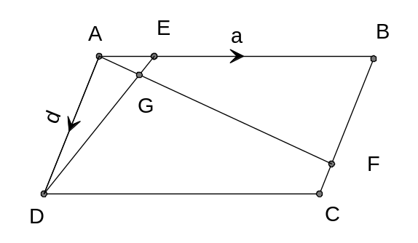

b) Determine the ratios in which 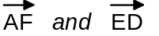 intersect each other, if the intersection point is at G. (8)

